Solar Garden Yard Lights Specification

Features:

Warm white lighting for decorating
100% solar powered, wireless connection
Superbright LEDs, 100Lumens for whole night
Over 3 nights long lighting time, Waterproof IP65
Battery Support zero-voltage charging,Short circuit & Over charging/discharging protection.

Product Application Area:

- Courtyard/Garden
- Park
- Roadway/pathway
- Parking Lot
- Private road
- Sidewalk
- Public square/ plaza

Product Details:

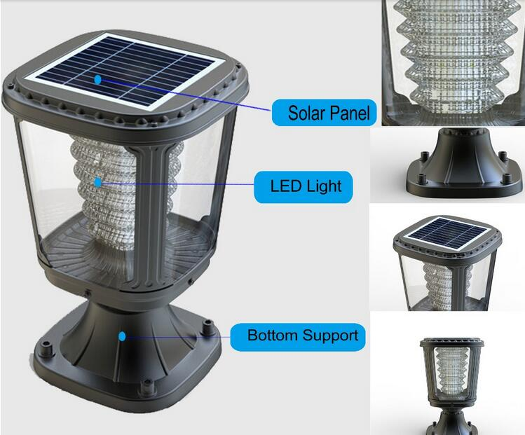

Installation Instruction:

